Final Project Design Phase
Computer Science - Week 11
Oct 3, 2026 - Version 0.0.4

For complete instructions and project ideas, refer to the assignment in Canvas. Specifically, review the final project requirements before you continue below. If you have not reviewed the project requirements in Canvas (you might have to go to the modules view and check the current or past week's content), you will not be able to properly complete the parts below. In addition, it may be helpful to review the information on this Drafter documentation page.

0) Project Planning and Preparation
Successful programmers spend time planning before they begin coding. After reviewing the project requirements, answer the following questions to help guide your design and development process.
- What concepts from class or previous assignments might help you complete this project? Which programming concepts (loops, conditionals, lists, classes, etc.) do you expect to use? What programming skills do you want to improve while completing this project?
I think the best thing thats going to help me with this project is the understanding of dataclasses. The one thing that I would like to most improve on is my drafter capabilities. I expect to use Drafter, For loops, If statements.

- Which parts of the project do you expect to be the easiest for you? The hardest? Why?
I think the easiest would be setting up all the dataclasses I will need only because I understand it so well and have worked with them before. The hardest part that i will run into will probably be working with the point system and properly give points to people.

- Even though you have not yet designed the final project, estimate which tasks will likely require the most time and effort? Which features or components should be implemented first?
I think the thing that will take the most time is giving the player the option to pick how many numbers they want to choose from but a set amount. I would want to work on the higher or lower buttons first and see if it will work the proper amounts.

- What distractions might interfere with your work and how will you minimize them? What resources will you need available while working? What questions, if any, do you still have about the assignment requirements?
My biggest distractions would probably be other people or just social media. I think the best way for me would be removing those issues from my area such as getting rid of my phone or going into a separate study room.

1) Site Diagram
Create a mock-up of your planned website. We suggest you make the mockup on paper, although you can also use software like PowerPoint or Slides to make a mockup. There is other design software that could also be used, but we strongly encourage you to keep it simple. Do not spend more than 15-30 minutes detailing the mock-up. Your goal should be to make a very quick and dirty diagram, to show that you have some kind of idea.

We recommend drawing each page as a rectangle, and laying out the text, buttons, and other components inside. Then, use arrows to indicate links between pages. Label each page the way you will name each function, and then put labels on the arrows to indicate what the button links. Also write down any parameters that should come into the pages.

In addition to the pages and routes, write down what fields your `State` will have, both their names and types. Think clearly about what data will need to be persistent across the entire website.

Add photo(s) or screenshot(s) of your website mock-up and labeled diagram on the next page.
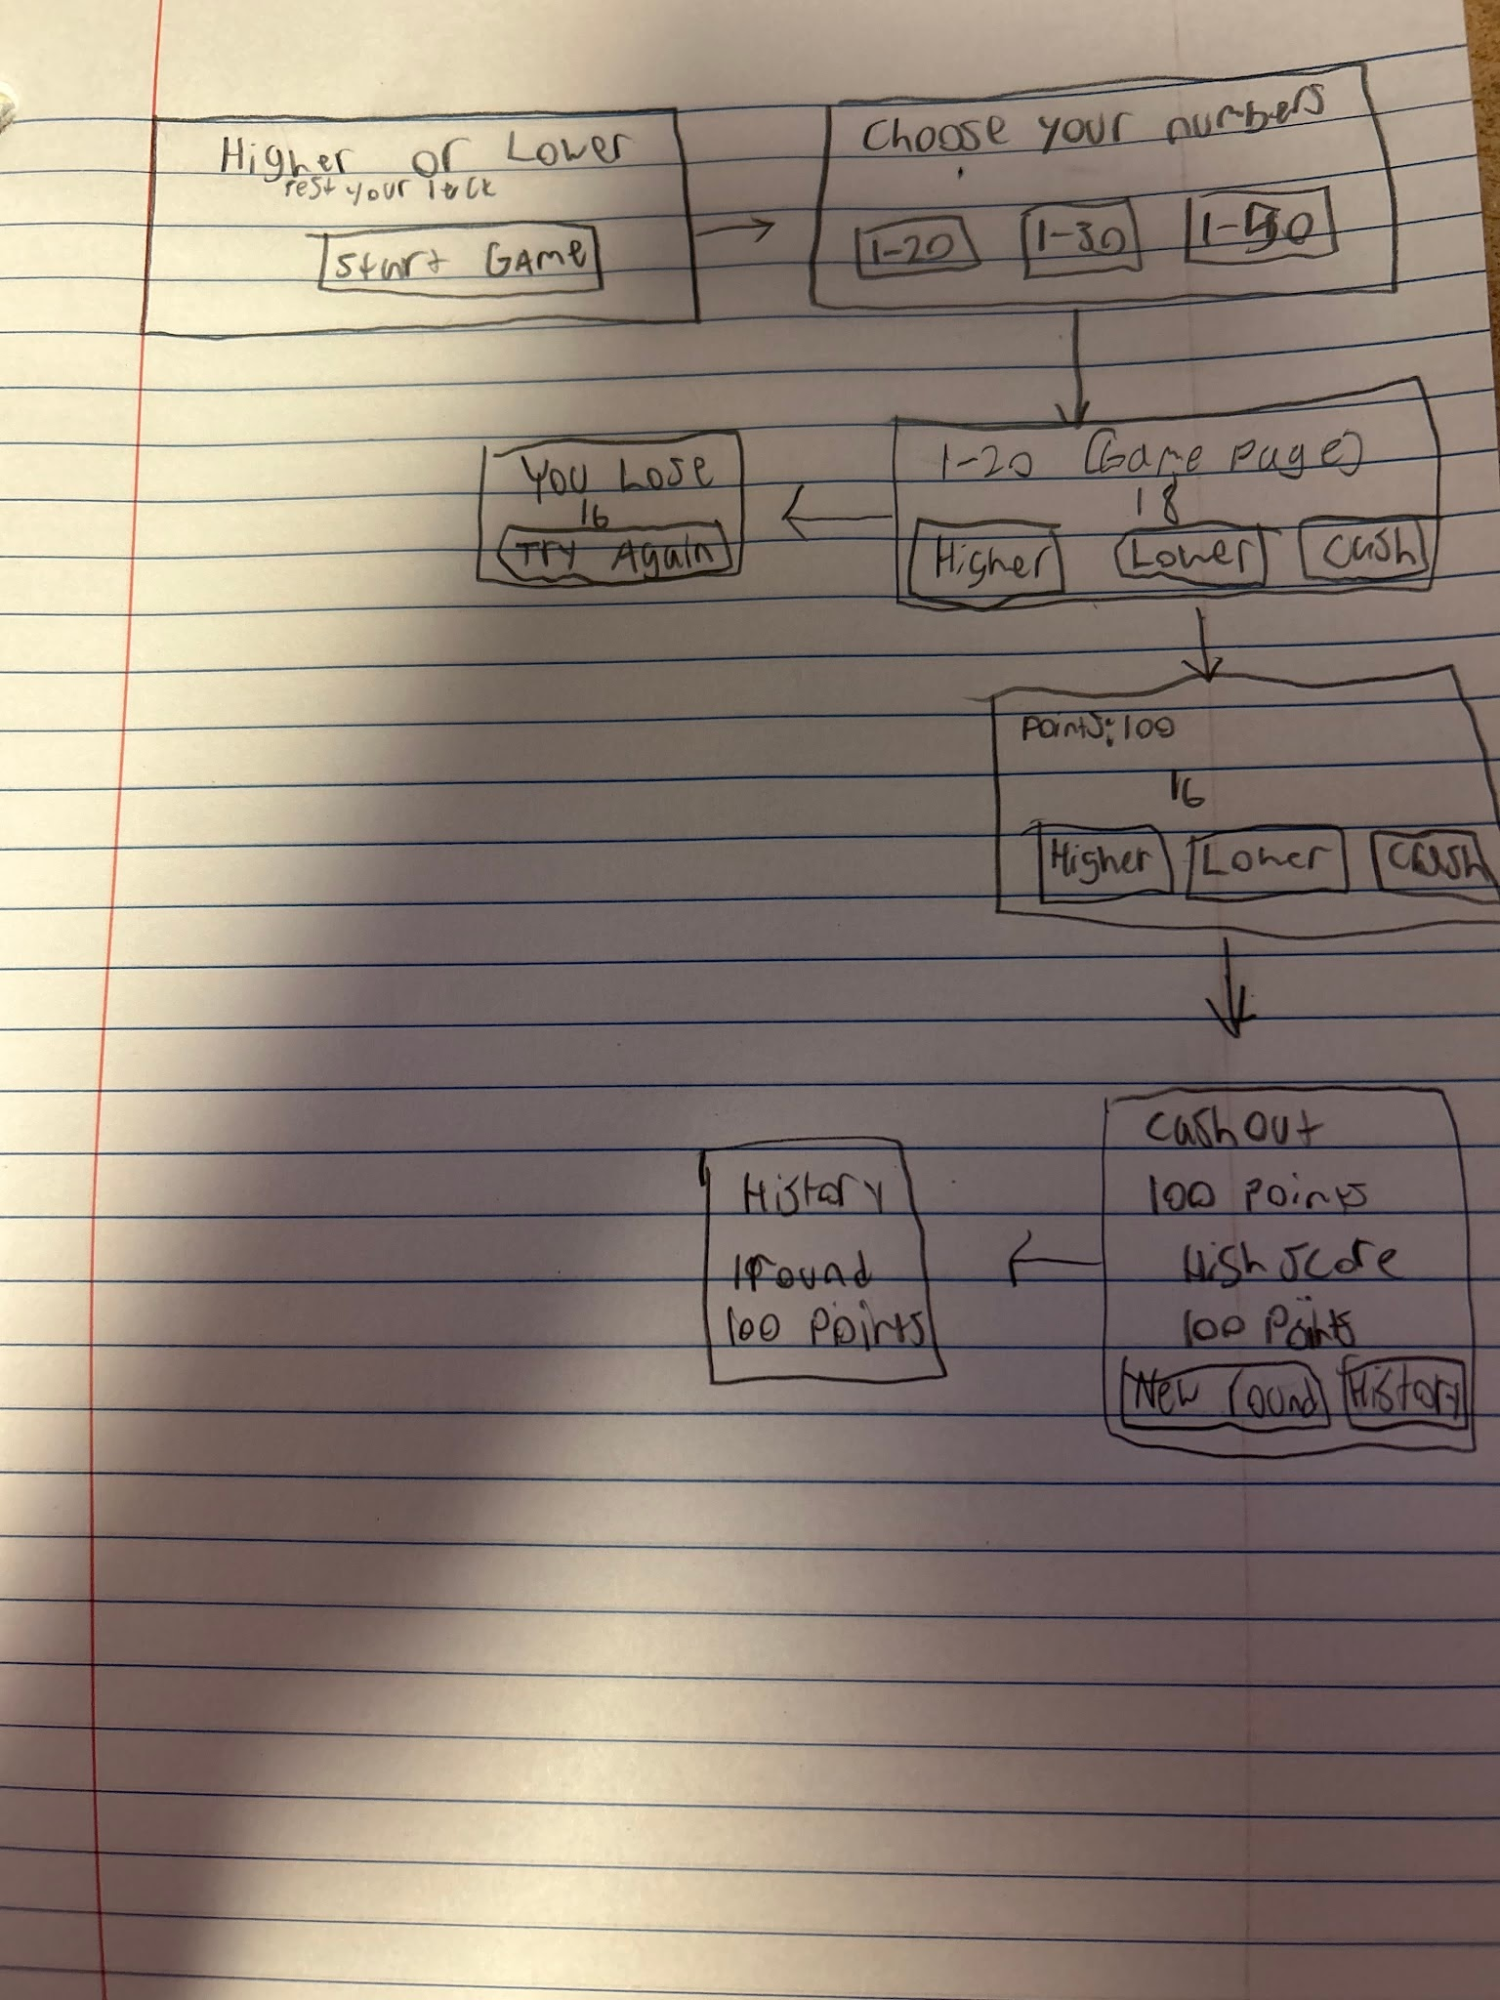

2) Implementing Requirements
This table should serve as a draft for how you will implement the requirements into your final project. You may change your ideas later on, but your final site must fulfill all the requirements.

Requirement | Implementation
Purpose/Functionality  A 1-2 sentence description of the purpose or functionality of your site | The purpose of this project is to understand the value of chance percentages. Also a game to play for sheer entertainment
State Dataclass Attributes  Minimum of 4 attributes, one of which must be a list/dict of instances of your second dataclass.  Briefly describe each attribute, its type, and how it will be meaningfully modified throughout the site. | score: int, This holds the numerical value of the players score.  current_number: int , This stores the current number that the player is going off of.  rounds_played: int, this stores the amount of rounds played in the game.  history: list[Round], list containing the Round dataclass
Second Dataclass  Your second dataclass, including its attributes, their types, and how they will be meaningfully modified (if they are modified) | Class Round  round_number: int, store the value of the round  player_choice : str, this will play as when the player picks “Higher”, “Lower”, or “Cash Out”  result : str, stores the outcome of the of the round “Win”, “Loss”, or “Cash Out” which will ultimately produce the score.  Score_after_round: int, stores the score after the round is completed.
Routes (minimum 7)  The names of your route functions | /home  /start_game  /higher  /lower  /cash_out  /history  /stats
Pages (minimum 5)  A brief description of the pages in your site | Home page: Start button, Small description  Game page: Main gameplay, Higher, lower, cashout button  Stats page: Gives you the statistics of the game.  History page: rounds number, player choices, result, score after the game.  Cashout page: The total score from the round played including the highest score and your score.
User Input (minimum 3)  Description of user input components (TextBox, TextArea, CheckBox, or SelectBox) and their purposes  For more information on these input types, see Drafter Documentation. | “Higher”, “Lower”, “Cash Out”, “1-20”, “1-30”, 1-50” (Select Boxes): The “Higher” and “Lower” box are inputs the the player choices to pick if their predicted number is higher or lower then the number given. The “Cash Out” button will end the game and tally up the score given. The “1-20” etc. number choice how many numbers are in the full game. “Probability numbers” Check Box: Wether this is on or off if on it'll show the percentages of the higher or lower and if off it will not.
If Statements (minimum 3)  Brief description of what will be evaluated in your if statements and how they will meaningfully change the logic of the site | If 1: Checks the players guess if the number is higher or lower compared to their input given if they match they get points and move on if its wrong they lose their points and they have to start over.  If 2: Checks if the probability check box is on if its checked it will show the percentage of the chance next to the higher or lower buttons and if its not it will not show.  If 3: Updating the high score when a player cashes out it will compare with the current high score. If its higher it will update and save the next highscore.  If 4: The range selection. This will help the code understand what number range is being played. This is chosen by the button that player chooses for the gameplay.
Loop (minimum 1)  This loop must iterate over the list/dict of dataclass instances in your State attribute.  Description of this loop and why it is meaningful to the site | This loop will use a for loop that goes through the game_history list which stores the Round dataclass and each of the statements in the Round dataclass will hold information of the current turn. This helps to create the History page.

LLM Conversation
If you used an LLM in any part of this work, copy and paste every part of that conversation below. Otherwise, you may be given a zero for the assignment. Obviously, these words will not all be yours, and this is the exception to the requirement at the top of this assignment that all responses be in your own words. If you did not use an LLM to assist you in this assignment, simply say so below.
Replace this text with your answer.

Final Submission
When you are finished, download this file as a Word Document (docx) and upload the file to the appropriate assignment on Canvas.

